**DSA LAB**

**NAME:SAFDAR ALI**

**REG NO: 084**

**1.Write a menu-driven program to perform different operations with queue such a**

**Enqueue ( ), Dequeue( ) and Display Queue( )**.

**Source code:**

#include <iostream>

using namespace std;

#define SIZE 5

class Queue {

int arr[SIZE];

int front, rear;

public:

Queue() {

front = -1;

rear = -1;

}

void enqueue(int x) {

if (rear == SIZE - 1) {

cout << "Queue Overflow!\n";

return;

}

if (front == -1) front = 0;

arr[++rear] = x;

cout << x << " enqueued.\n";

}

void dequeue() {

if (front == -1 || front > rear) {

cout << "Queue Underflow!\n";

return;

}

cout << arr[front++] << " dequeued.\n";

}

void display() {

if (front == -1 || front > rear) {

cout << "Queue is empty!\n";

return;

}

cout << "Queue elements: ";

for (int i = front; i <= rear; i++) {

cout << arr[i] << " ";

}

cout << "\n";

}

};

int main() {

Queue q;

int choice, val;

do {

cout << "\n--- Queue Menu ---\n";

cout << "1. Enqueue\n2. Dequeue\n3. Display\n4. Exit\n";

cout << "Enter your choice: ";

cin >> choice;

switch (choice) {

case 1:

cout << "Enter value to enqueue: ";

cin >> val;

q.enqueue(val);

break;

case 2:

q.dequeue();

break;

case 3:

q.display();

break;

case 4:

cout << "Exiting...\n";

break;

default:

cout << "Invalid choice!\n";

}

} while (choice != 4);

return 0;

}

**Output:**

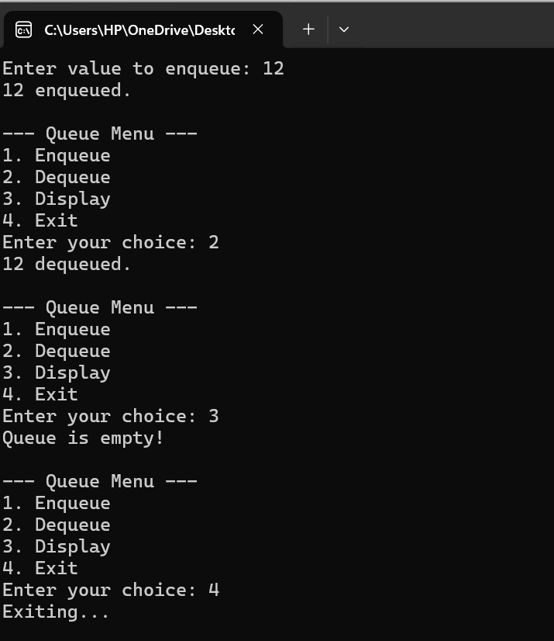

**2.In this Exercise, you have to take a single string as input. Using this input string, you have**

**to create multiple queues in which each queue will comprise of separate word appearing**

**in the input string. Example: String = “Data Structure and Algo”**

**Q1 = D → a → t → a**

**Q2 = S → t → r → u → c → t → u → r → e**

**Q3 = a → n → d**

**Source code:**

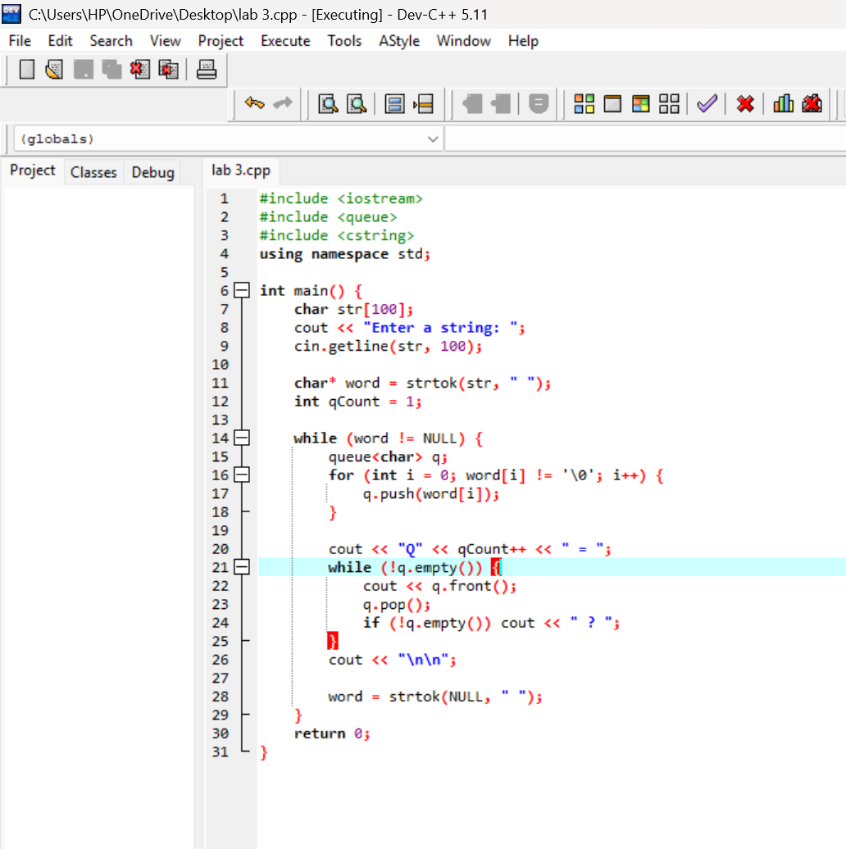

**Output:**

